MED D - Test Claim - Calculating Quantity of Eye Drops

Definition | An eye drop is a liquid medication to be applied in very small amounts to the eyeball.
Instructions for Running a Test Claim | How many total drops are used per day (both eyes)?  Example: The caller states they use 2 drops in the right and left eye twice a day. This would equal a total of 8 drops per day.  
Common Direction (SIG) Codes | Gtt - Drop  OU - Each Eye  OD - Right Eye  OS - Left Eye
Additional Notes | Conversions for drops may need to be manually calculated. Most eye drop are calculated based on a standard of 15 drops per 1ml.  Conversions
Additional Notes | 1 ml | = | 15 drops |  | 10 ml | = | 150 drops
Additional Notes | 5 ml | = | 75 drops |  | 15 ml | = | 225 drops
Additional Notes | However, based on manufacturer recommendations, certain eye drops do not follow this standard. Refer to Eye Drops Conversion Exceptions table.
Eye Drop Conversion Exceptions | Exceptions include:
Eye Drop Conversion Exceptions | Product |  |  | Eye Drops Conversion
Eye Drop Conversion Exceptions | Azasite |  |  | 2.5ml = 20 drops (expires after 14 days)
Eye Drop Conversion Exceptions | Cosopt PF |  |  | 60 Single-Use Containers  Calculate based on number of vials used per day  - There are enough drops in a single use container to treat 1 or both eyes once a day.
Eye Drop Conversion Exceptions | Elestat |  |  | 5ml = 150 drops
Eye Drop Conversion Exceptions | FML Liquifilm |  |  | 5ml = 75 drops
Eye Drop Conversion Exceptions | Lotemax 0.5% Gel |  |  | 5ml = 125 drops
Eye Drop Conversion Exceptions | Lumigan .01% |  |  | 2.5ml = 75 drops
Eye Drop Conversion Exceptions | Lumigan .03% |  |  | 2.5ml = 75 drops
Eye Drop Conversion Exceptions | Optivar |  |  | 6ml = 155 drops
Eye Drop Conversion Exceptions | Pataday |  |  | 2.5ml = 69 drops
Eye Drop Conversion Exceptions | Restasis |  |  | 30 Unit dose vials per package  Calculate based on number of vials used per day  - There are enough drops in a single use container to treat 1 or both eyes once a day.
Eye Drop Conversion Exceptions | Travatan |  |  | 2.5ml = 80 drops
Eye Drop Conversion Exceptions | Vigamox |  |  | 3ml = 42 drops
Eye Drop Conversion Exceptions | Xalatan |  |  | 2.5ml = 80 drops (expires 6 weeks after opening)
Eye Drop Conversion Exceptions | Zymaxid |  |  | 2.5ml = 80 drops
What if Test Claim Rejects | Review the rejection code to determine what caused the rejection. Once the rejection code is identified, access the proper work instruction and job aids in theSource to help you resolve the issue.

Example
Cosopt Sol
22.3-6.8

Directions: Use 2 drop in each eye daily



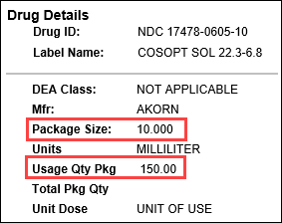 |  |  | 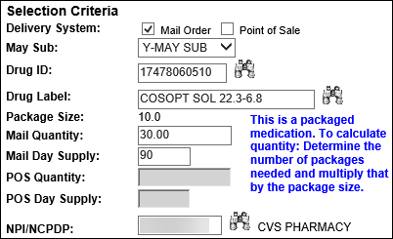
Calculation
Drops per Day | X | Days |  | = | Drops Needed
4 | X | 90 |  | = | 360
Drops Needed | ÷ | Usage Quantity Package  (from PeopleSafe) |  | = | Total Number of Bottles
360 | ÷ | 150 |  | = | 2.4 (Round up to 3)
Total Number of Bottles | X | Package Size  (from PeopleSafe) |  | = | Test Claim Quantity
3 | X | 10 |  | = | 30

Example
Lumigan Sol 0.01%

Directions: Use 1 drop in each eye twice daily

Note: This is an eye drop exception: There are 75 drops per package.



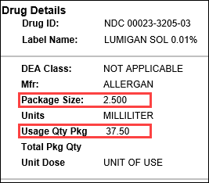 |  |  | 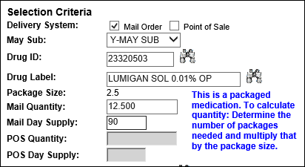
Calculation
Drops per Day | X | Days |  | = | Drops Needed
4 | X | 90 |  | = | 360
Drops Needed | ÷ | Usage Quantity Package  (Exception 2.5ml=75drops) |  | = | Total Number of Bottles
360 | ÷ | 75 |  | = | 4.8 (Round up to 5)
Total Number of Bottles | X | Package Size  (from PeopleSafe) |  | = | Test Claim Quantity
5 | X | 2.5 |  | = | 12.5

Example
Cosopt PF 2%/0.5%

Directions: Use 1 drop in each eye in the morning and 1 drop in each eye in the evening

Note: This is an eye drop exception: Calculate based on number of vials used per day. There are enough drops in a single use container to treat 1 or both eyes once a day.

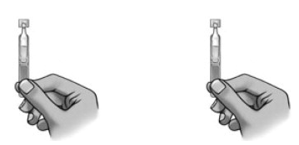

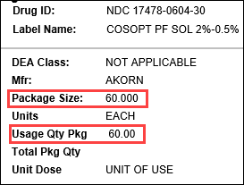 |  |  | 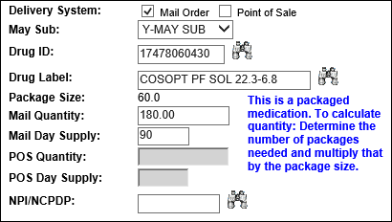
Calculation
Vials per Day | X | Days |  | = | Vials Needed
2 | X | 90 |  | = | 180
Vials Needed | ÷ | Usage Quantity Package |  | = | Total Number of Packages
180 | ÷ | 60 |  | = | 3
Total Number of Packages | X | Package Size  (from PeopleSafe) |  | = | Test Claim Quantity
3 | X | 60 |  | = | 180

Top of the Document

Related Documents
MED D - Test Claim Index
Calculating Quantities for Packaged Medication

Parent SOP: CALL-0049: Customer Care Internal and External Call Handling
Abbreviations / Definitions: Customer Care Abbreviations, Definitions, and Terms

Top of the Document

Not To Be Reproduced Or Disclosed to Others Without Prior Written Approval
ELECTRONIC DATA = OFFICIAL VERSION – PAPER COPY – INFORMATIONAL ONLY

